APPENDIX A
PHOTOGRAPHS TAKEN DURING JIV AT 18” TEBIDABA-BRASS PIPELINE AT KALATORU COMMUNITY, SOUTHERN IJAW L.G.A, BAYELSA STATE ON 5TH MAY, 2024.
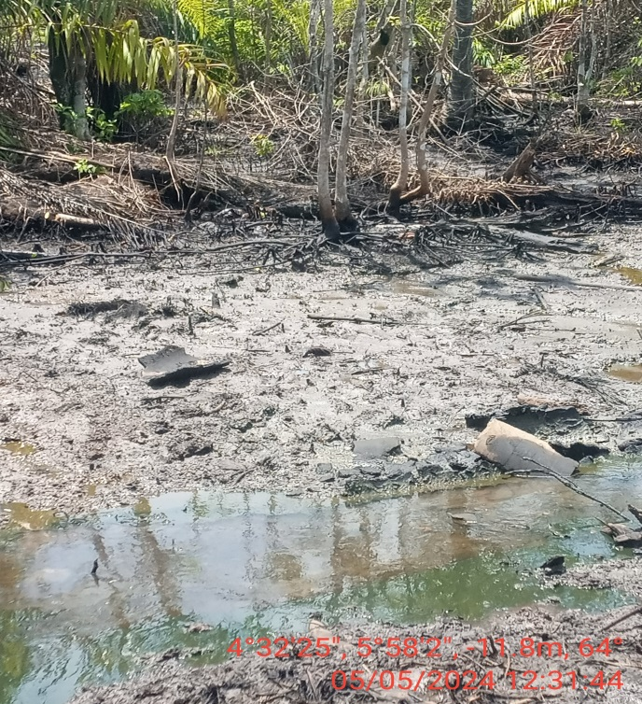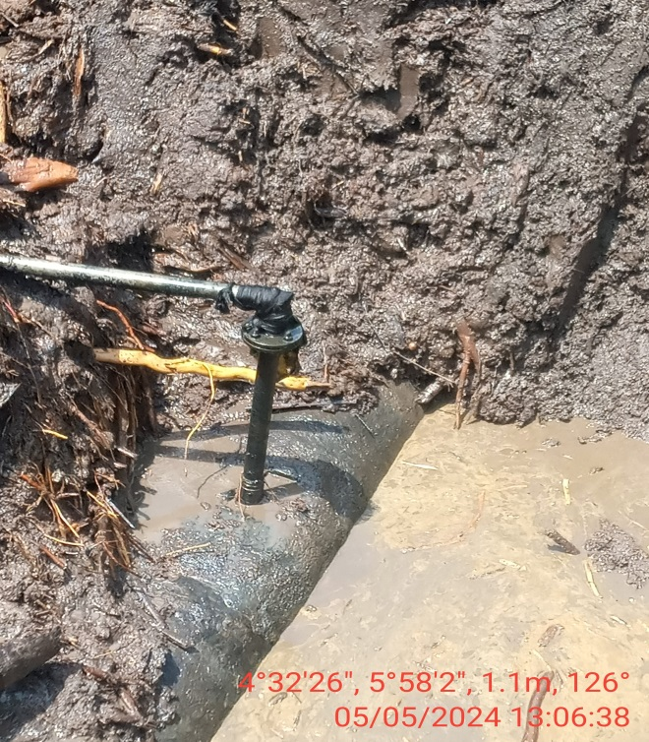
Fig. 1: The incident area before excavation. Fig. 2: 2” valve at 12 o’ clock position.
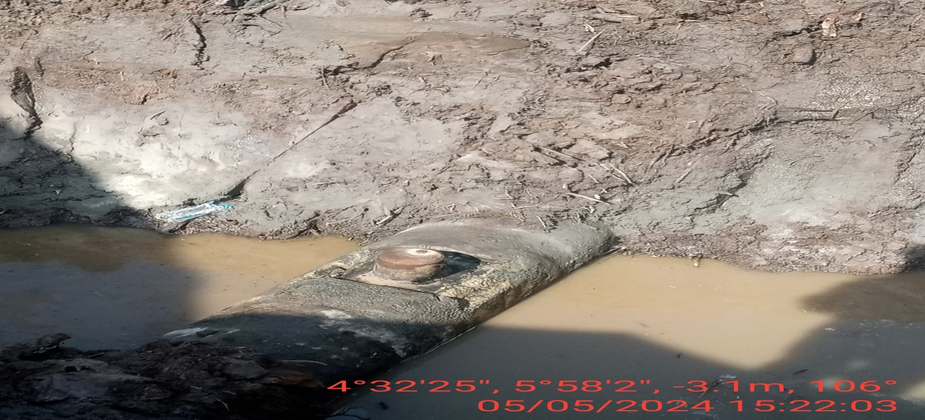
Fig. 3: the incident point after repairs.

